# C2- S2-**PRACTICE**

# **Objectives** of this practice

**FILE NAVIGATION**

o Be able **to search files** by name, by extension

*Ex: search files containing the word banana on the folder C:/a/b/c*

o Be able to access to /Download or /Desktop

o Knows the **difference** between a **folder** and a **file**

o Be able to access to any **folder and sub folders**

**QUICK ACCESS AREA**

o Be able to access **pin or unpin** folders quick access

**FILE AREA**

o Be able to **hide or display columns**

o Be able to **sort files** by name, date modified, size...

o Be able to **access the parent folder**, go back

**RECYCE BIN**

o Be able to **restore** files

o Be able to **delete** files **permanently**

# **How to work** on this practice?

|  |  |
| --- | --- |
| 20min | Read **individually the handout** to understand how to use file explorer |
| 10min | In team of 4: explain what you understood or did not understand |
| 60min | Do the 5 challenges below |

# CHALLLENGE 1

Understand and explain the meaning of the following folders:

|  |  |
| --- | --- |
| FOLDER | MEANING |
|  |  |
|  |  |
|  |  |
|  |  |
|  |  |

# CHALLLENGE 2

* Open File explorer and create the following folder and sub folders:

C:\Users\LENOVO\Desktop\PNC-2024\TERM1\BCU\CHAPTER-2\S2-PRACTICE

* Inside this folder, create the following file content

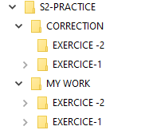

# CHALLLENGE 3

Search for file and explain how you did it

|  |  |
| --- | --- |
| SEARCH | HOW DID YOU DO |
| Files Containing “test” |  |
| Files bigger than 10 MB |  |
| Files type PNG |  |
| Files modified this week |  |

# CHALLENGE 4

Following the Challenge 2 pin the folders to quick access as below:

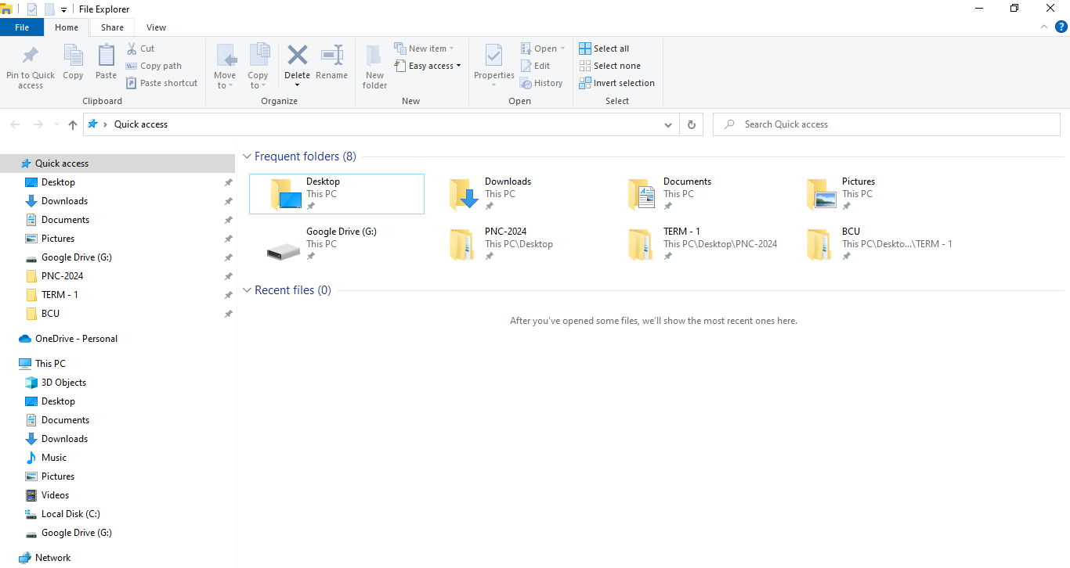

# CHALLENGE 5

* Create the following folder and sub folders
* Open it with File explorer

C:\Users\LENOVO\Desktop\PNC-2024\TERM1\BCU\CHAPTER-2\S2-PRACTICE\TEST-BIN

* Copy the files from the folder FILES that your teacher given you before
* Delete file2, file3, file6, file9 and restore it from the bin.